The below Courses / Surveys are required for Theater Clearance into country. The courses below are a COCOM requirement that CU&LP desk officers will enter the completion dates into APACS to gain Theater and Country clearance. These are mandatory and must be complete before 16 Feb 18. Delays in clearance can cause Team Ldrs to be at risk for orders putting Mission at risk since NGB requires approved clearance before they will cut Active Duty orders for Mission.
Certificates for the below courses should be uploaded by HRAs / ROTC Cadre into CULP Sharepoint for verification and the cadets should enter the completion dates into Army Cadet Portal under the pre deployment Task list tab so CU&LP can coordinate for Clearance. Bi weekly status will be sent to BDEs and Mission CDRs for cadets that are delinquent.
Level 1 Antiterrorism (AT) Awareness Training:
1. Level 1 AT Awareness Training is available on Joint Knowledge Online (JKO) https://jkodirect.jten.mil . Enroll in Course # JS-US007-14.
a. Level 1 AT Awareness Training must be current and completed within 12 months (one (1) year) prior to entry into the AOR.
b. JKO Help Desk, Monday - Friday 0700-1900 EST
i. E-mail: jkohelpdesk@jten.mil
ii. COMM: 757-203-5654 or DSN: 668-5654
Isolated Personnel Report (ISOPREP) or PROFILE Survey:
Completion Instructions:
1. Purpose: Personnel Recovery preparation is required to prepare for a situation when a traveler needs to be authenticated after they have become isolated, captured, missing, or detained; whether through accident (e.g., vehicle breaks down while traveling to a location), political turmoil (e.g., riot) or criminal/terrorist action (e.g., kidnapping). Travelers should be prepared to survive unassisted for no less than 96 hours.
2. DoD and DoD sponsored travelers will have a Digital ISOPREP submitted prior to entry into the AOR. More restrictive requirements may be mandated by COCOM.*
3. ISOPREPs should be filed electronically on the Personnel Recovery Mission Software (PRMS).
4. The PRMS software allows two (2) digital pictures smaller than 200k. Not mandatory for Certificate of completion* If having issues skip uploading Pics.
5. Fingerprints are not required on the ISOPREP form.
6. https://prmsglobal.prms.af.mil/prmsconv/Profile/Survey/start.aspx Link for NIPR to fill out
7. https://prmsglobal.prms.af.smil.mil/prmsconv/Login/FAQ.aspx Click Link for assistance or see Tab E & F to App 6 Annex U for completing ISOPREP thru CITRIX and Troubleshooting help guide.
8. Contact Information PRMS Helpdesk for more assistance below:
a. DSN: 312-273-3701
b. COMM: 586-239-3701
SERE 100.2 Level A Training
Purpose: Personnel Recovery preparation is required to prepare for a situation when a traveler needs to be authenticated after they have become isolated, captured, missing, or detained; whether through accident (e.g., vehicle breaks down en route to a location), political turmoil (e.g., riot) or criminal/terrorist action (e.g., kidnapping). Travelers should be prepared to survive unassisted for no less than 96 hours.

- SERE 100.1 Level A and SERE 100.1 Civilians Only courses are obsolete; however, if completed before 18 May 2016, it will be accepted until the 3 year requirement expires. If traveler’s currency expires after 18 May 2016, he/she must complete SERE 100.2 Level A below:

- Military Personnel ( Cadre & Cadets)
a. Go to http://jko.jten.mil / (this site can be used by non-government personnel,
b. Click on “Take Courses – CAC” *
c. Click on “Login Using My CAC” 2
Last Updated - 10-Feb-17
d. Click the “Course Catalog” tab
e. In the PREFIX FIELD, enter J3T
f. In the NUMBER FIELD, enter A-US1329, then click on “Apply Filters”
g. Click the “Enroll” button
h. Next, click on the “My Atlas” tab, then launch the course from the “My Training” section in order to receive course credit. You WILL NOT RECEIVE CREDIT if you launch the course using the “Preview” icon from the “Course Catalog” section. Ensure that upon completion of each lesson, you select the NEXT LESSON button to successfully complete the course. To return to the homepage, click the “My Atlas” tab.
i. Once completed, enter the completion dates into ACP and CULP Sharepoint for CU&LP International Programs Division to enter on the APACS country/theater clearance request.

* If you do not have a CAC, click on “Take Courses – non CAC,” and an automated email window will pop up; fill out the requested information, and your email will be sent to the JKO Help Desk. JKO HELP DESK: (757) 203-5654 or jkohelpdesk@jten.mil

Combatting Trafficking in Persons (CTIP)
1. Web Based http://ctip.defense.gov/Training/Refresher/Joint-Knowledge-Online-JKO-Refresher/
a. Click "Take Courses" and login with your CAC on the next page (Click here for full instructions)
b. Select "Course Catalog" and filter the course title by entering the course number "J3TA-US1281" in the filter box above the Number column and then select "Apply Filters" to find the course and enroll.
c. If you encounter any difficulties trying to enroll, please contact the JKO Help Desk at jkohelpdesk@jten.mil or 757-203-5654 for assistance.
2. Mobile Phone Based
a. Click "Take Courses" and login with your CAC on the next page (Click here for full instructions)
b. Select "Course Catalog" and filter the course title by entering the course number "J7OP-US1126" in the filter box above the Number column and then select "Apply Filters" to find the course and enroll.
c. Record your Personal Identification Number (PIN) that is activated as part of completing the JKO Mobile course.
d. Download and Install the JKO Mobile App on your mobile device, sign in using your PIN, and download the CTIP course from the App’s “Library” section.
e. Complete training course on your mobile device. Course completion records are sent to the JKO desktop system upon a successfully “Sync” of your device (“Sync” requires connection via Wi-Fi or a mobile data plan). Your mobile course completion certificates are stored and available to print from the “Open My Training History” section of your JKO desktop account.
NOTE: You can complete the CTIP course via the “Public access” area on the JKO Mobile App. However, you will NOT receive a course certificate in your JKO training history.
Completing Pre Deployment Health Assessment (PDHA) on AKO (within 30 days of MSN)
The below survey is required before every deployment and is loaded into MEDPROS. Complete within 30 days of Mission and before arrival at Ft Knox Ky. A medical provider will review with Cadet during SRP week prior to Mission into Country. Enter AKO Army Knowledge Online.
Link : https://login.us.army.mil/suite/login/
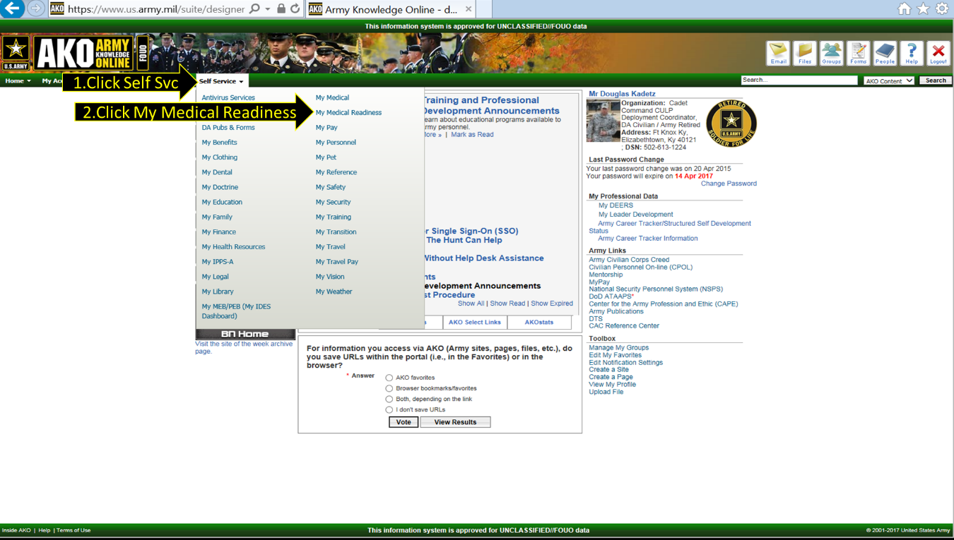
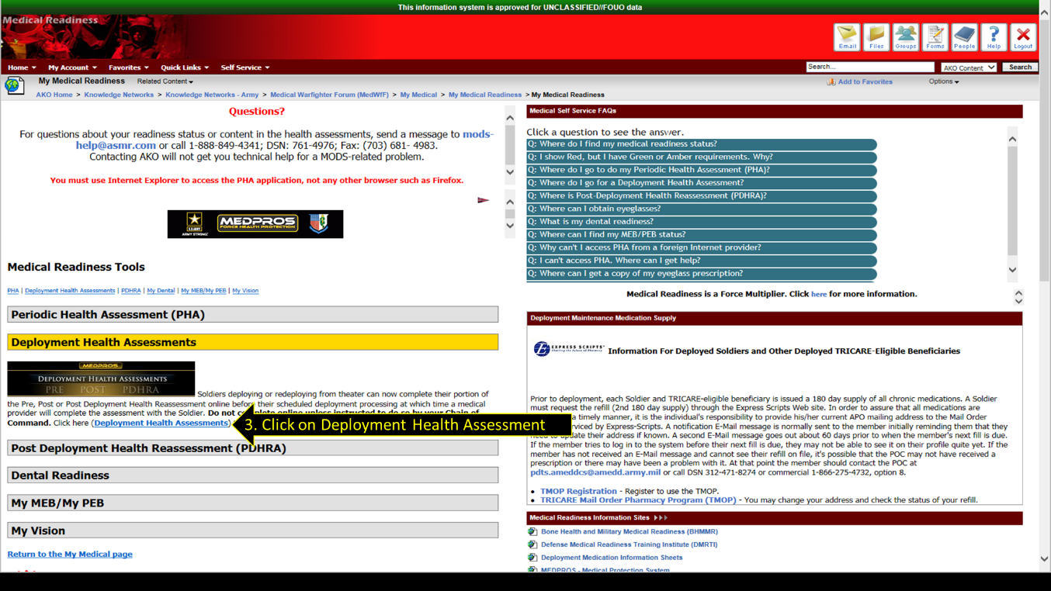
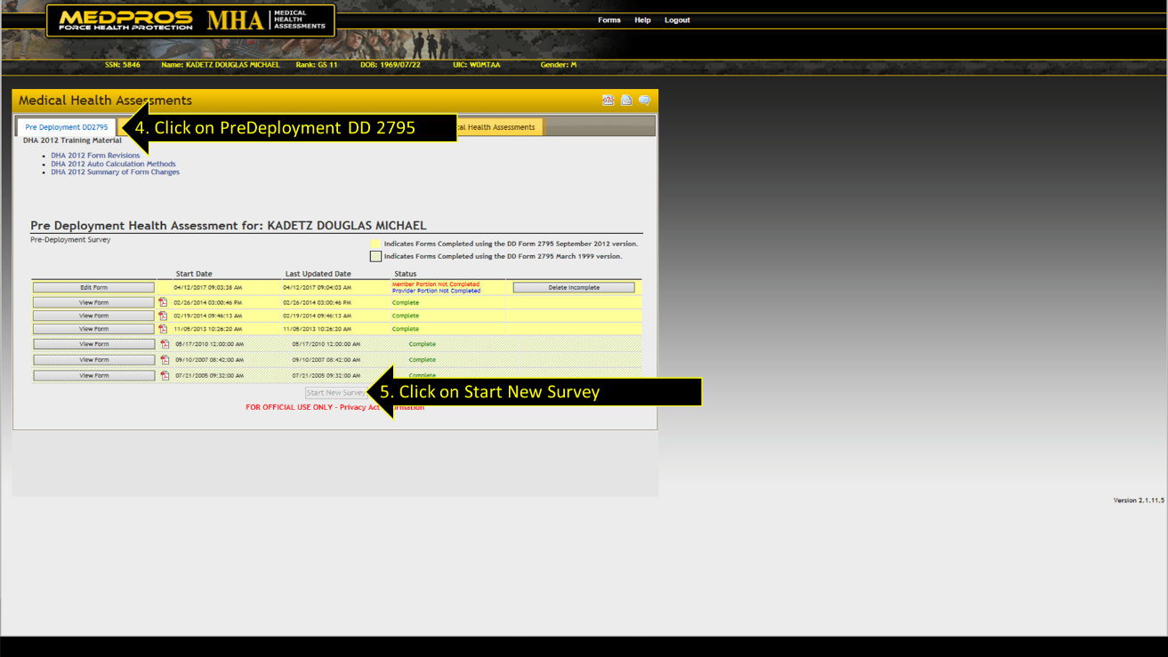
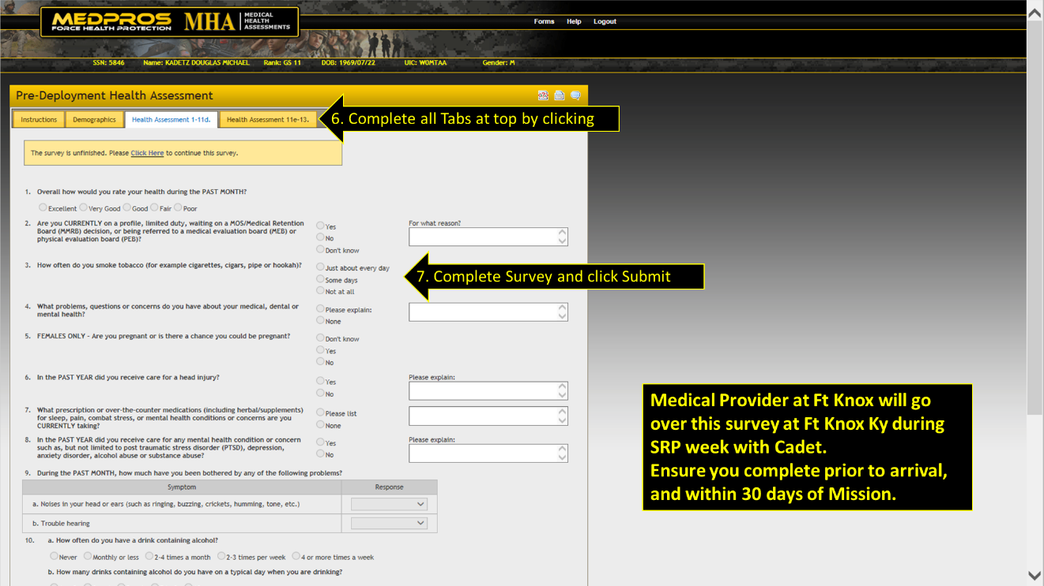
Enrolling in STEP Smart Traveler Enrollment Program (After receiving Passport)
The Smart Traveler Enrollment Program (STEP) is a free service to allow U.S. citizens and nationals traveling and living abroad to enroll their trip with the nearest U.S. Embassy or Consulate. Receive important information from the Embassy about safety conditions in your destination country, helping you make informed decisions about your travel plans. STEP helps the U.S. Embassy contact you in an emergency, whether natural disaster, civil unrest, or family emergency.
Click Link to get started: https://step.state.gov/step/ Note** Passport # required to enroll.
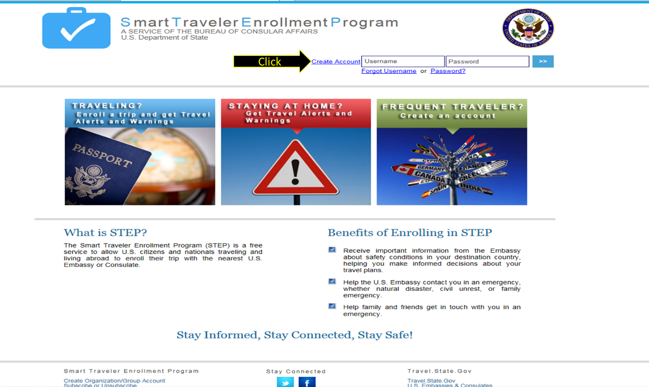
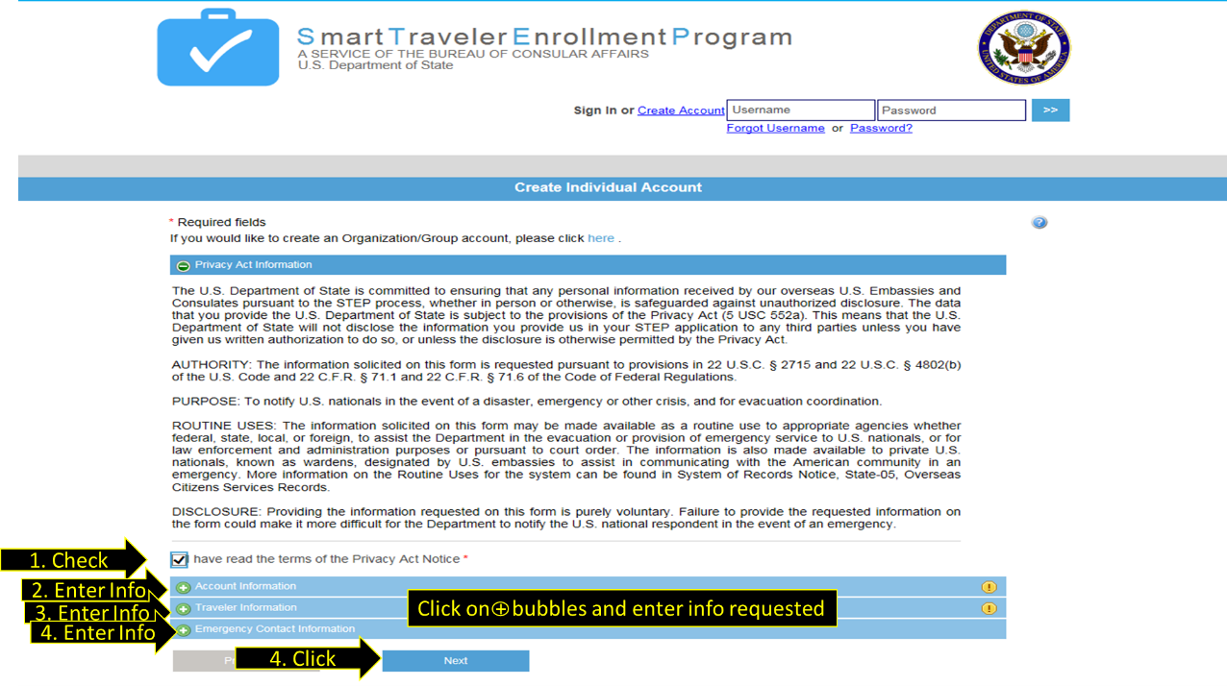
For questions concerning these instructions or issues contact below:
Mr. Douglas.m.kadetz.civ@mail.mil
CULP Deployment Coordinator / Passport Agent
Cultural Understanding & Leadership Program
59 Abel St (Bldg 6557) Creaden Hall
Cadet Command G3 Ft Knox Ky 40121
Office: 502-613-1224
DSN: 312-983-1224
Cell: 502-963-7651

